Assignment 18 (February 13 – 18)

1. Find the polar and the exponential form of the following complex numbers:
- 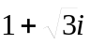 4) 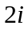 7) 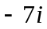
- 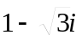 5) 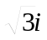 8) 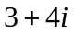
3) 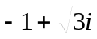 6) 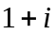 9) 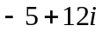

2. Calculate the following:
1) 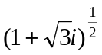; 2) 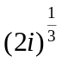; 3) 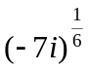

3. Find the particular integral and the complementary function, the general solution and the definite solution of the following:

4. Solve the following equations:
a) 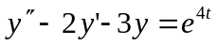,
b) 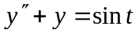,
c) 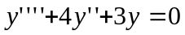,
d) 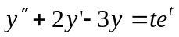.
5. Expand 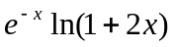 in ascending powers of as far as the term in 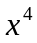. State the range of values of for which this series is valid.

